Drosophila HCN mediates gustatory homeostasis by preserving sensillar transepithelial potential in sweet environments

MinHyuk Lee^{1,2,3}, Se Hoon Park⁴, Kyeung Min Joo², Jae Young Kwon³, Kyung-Hoon Lee², and KyeongJin Kang^{1*}

Affiliations:
¹Neurovascular unit research group, Korea Brain Research Institute, Daegu, 41062, Republic of Korea.
²Department of Anatomy and Cell Biology, Sungkyunkwan University School of Medicine, Samsung Biomedical Research Institute, Samsung Medical Center, Suwon, 16419, Republic of Korea.
³Department of Biological Sciences, Sungkyunkwan University, Suwon, 16419, Republic of Korea.
⁴Department of Brain Sciences, DGIST, Daegu, 42988, Republic of Korea.

*Corresponding author. Email: kangkj@kbri.re.kr

Abstract
Establishing transepithelial ion disparities is crucial for sensory functions in animals. In insect sensory organs called sensilla, a transepithelial potential, known as the sensillum potential (SP), arises through active ion transport across accessory cells, sensitizing receptor neurons such as mechanoreceptors and chemoreceptors. Because multiple receptor neurons are often co-housed in a sensillum and share SP, niche-prevalent overstimulation of single sensory neurons can compromise neighboring receptors by depleting SP. However, how such potential depletion is prevented to maintain sensory homeostasis remains unknown. Here, we find that the Ih-encoded hyperpolarization-activated cyclic nucleotide gated (HCN) channel bolsters the activity of bitter-sensing gustatory receptor neurons (bGRNs), albeit acting in sweet-sensing GRNs (sGRNs). For this task, HCN maintains SP despite prolonged sGRN stimulation induced by the diet mimicking their sweet feeding niche, such as overripe fruit. We present evidence that Ih-dependent demarcation of sGRN excitability is implemented to throttle SP consumption, which may have facilitated adaptation to a sweetness-dominated environment. Thus, HCN expressed in sGRNs serves as a key component of a simple yet versatile peripheral coding that regulates bitterness for optimal food intake in two contrasting ways: sweet-resilient preservation of bitter aversion and the previously reported sweet-dependent suppression of bitter taste.

Introduction
Glia-like support cells exhibit close physical association with sensory receptor neurons, and conduct active transcellular ion transport, which is important for the operation of sensory systems¹. In mammals, retinal pigment epithelial (RPE) cells have a polarized distribution of ion channels and transporters. They provide an ionic environment in the extracellular space apposing photoreceptors to aid their light sensing². Likewise, knockdown of Drosophila genes encoding the Na⁺/K⁺ pump or a K⁺ channel in the supporting glial cells attenuates photoreceptors³. In addition to creating an optimal micro-environment, transepithelial potential differences (TEPs) are often generated to promote the functions of sensory organs. For example, the active K⁺ transport from the perilymph to the endolymph across support cells in the mammalian auditory system⁴ generates high driving forces that enhance the sensitivity of hair cells by increasing K⁺ and Ca²⁺ influx through force-gated channels. Similar designs have been found in insect mechanosensory^{5,6} and chemosensory organs^{7,8}, providing models to study physiological principles and components of TEP function and regulation. Many of insect sensory receptor neurons are housed in a cuticular sensory organ called the sensillum. Tight junctions between support cells separate the externally facing sensillar lymph from the internal body fluid known as hemolymph⁹. The active concentration of K⁺ in the dendritic sensillar lymph produces positive sensillum potentials (SP, +30~40 mV) as TEPs, which are known to sensitize sensory reception in mechanosensation¹⁰ and chemosensation^{11,12}.
Excitation of sensory neurons drains SP, accompanied by slow adaptation of the excited receptor neurons^{6,12}. This suggests that immoderate activation of a single sensory neuron can deplete SP, which decreases the activities of neurons that utilize the potential for excitation. Each sensillum for mechanosensation and chemosensation houses multiple receptor neurons¹. Therefore, overconsumption of SP by a single cell could affect the rest of the receptor neurons in the same sensillum, because the receptor neurons share the sensillum lymph. Indeed, the reduction of SP was proposed to have a negative effect on receptor neurons that are immersed in the same sensillar lymph; a dynamic lateral inhibition between olfactory receptor neurons (ORNs) occurs through “ephaptic interaction”, where SP consumption by activation of one neuron was proposed to result in hyperpolarization of an adjacent neuron, reducing its response to odorants^{13,14}. As expected with this SP-centered model, ephaptic inhibition was reported to be mutual between Drosophila ORNs^{13,15}, again because the ORNs are under the influence of a common extracellular fluid, the sensillar lymph. Such reciprocal cancellation between concomitantly excited ORNs may encode olfactory valence¹⁶ rather than lead to signal attenuation of two olfactory inputs. Furthermore, depending on neuron size, the lateral inhibition between ORNs can be asymmetric, albeit yet to be bilateral; larger ORNs are more inhibitory than smaller ones¹³. The size dependence was suggested to be due to the differential ability of ORNs to sink SP (referred to as local field potential in the study¹³), probably because larger cells have more membrane surface area and cell volume to move ions to or from the sensillar lymph.
Interestingly, gustatory ephaptic inhibition was recently found to be under a genetic, but not size-aided, regulation to promote sweetness-dependent suppression of bitterness¹⁷. This is accomplished by blocking one direction of ephaptic inhibition. The hyperpolarization-activated cation current in sGRNs through the Ih-encoded HCN is necessary to resist the inhibition of sGRNs laterally induced by bGRN activation. Furthermore, such unilateral ephaptic inhibition is achieved against cell size gradient¹⁷. Larger bGRNs are readily suppressed by the activation of smaller sGRNs, but not vice versa. Thus, HCN is implemented to inhibit bGRNs in terms of unilateral ephaptic inhibition when a bitter chemical is concomitantly presented with strong sweetness. Here, in addition to the ephaptic interaction, we find that the same HCN expressed in sGRNs promotes the activity of bGRNs as a means of homeostatic sensory adaptation, for which HCN prevents sGRNs from depleting SP even with the long-term exposure to the sweet-rich environment.

Results
HCN expressed in sweet-sensing GRNs is required for normal bitter GRN responses.
The hair-like gustatory sensilla in the Drosophila labellum are categorized into L-, i-, and s-type based on their relative bristle lengths. Each sensillum contains 2 (i-type) or 4 (s- and L-type) GRNs along with a mechanosensory neuron. The i- and s-type bristle sensilla contain both an sGRN and a bGRN, while the L-type bristle sensilla do an sGRN but no bGRN^{18–21}. As a model of gustatory homeostasis, we mainly examined the i-type bristles using single sensillum extracellular recording^{22–24} because of their simple neuronal composition. Compared to WT (w¹¹¹⁸ in a Canton S background), we observed reduced the spiking responses to 2 mM caffeine in two strong loss-of-function alleles of the HCN gene, Ih^{f03355} ^{25,26} and Ih^{MI03196-TG4.0}/+ (Ih-TG4.0/+)^{17,27} (Fig.1A). Note that Ih-TG4.0 is homozygous lethal¹⁷. A copy of the Ih-containing genomic fragment {Ih} rescued the spiking defect in Ih^{f03355}. The GRN responses to 50 mM sucrose were not altered in Ih mutants (Fig.1B). Although we observe here that Ih pertains to bGRN excitability, Ih was previously found to be expressed in sGRNs but not bGRNs¹⁷. To test whether HCN expression in sGRNs is required for bGRN activity, GRN-specific RNAi knockdown of Ih was performed with either Gr64f-²⁸ or Gr89a-Gal4²¹. Ih knockdown in sGRNs (Gr64f-Gal4), but not bGRNs (Gr89a-Gal4), led to reduced bGRN responses to caffeine (Fig.1C), indicating that HCN acts in sGRNs for a normal bGRN response. Unlike the results in Ih mutant alleles, the spiking response of Ih-knockdowned sGRNs (Gr64f cells) to 50 mM sucrose was increased (Fig.1D). Such differential effects of gene disruptions and RNAi on sGRN activity will be discussed with additional results below. Introduction of Ih-RF cDNA¹⁷ to sGRNs but not bGRNs restored the decreased spiking response to 2 mM caffeine in Ih^{f03355}, corroborating that sGRNs are required to express Ih for bGRN regulation (Fig.1E). Interestingly, ectopic cDNA expression in bGRNs of Ih^{f03355} but not in sGRNs increased the spiking response to 50-mM sucrose compared to its controls (Fig.1F), although the same misexpression failed to raise the spiking to 2-mM caffeine. These results suggest not only that Ih innately expressed in sGRNs is necessary for the activity of bGRNs, but also that Ih expression in one GRN may promote the activity of the other adjacent GRN in Ih-deficient animals.

Loss of Ih in sGRNs reduced the sensillum potential in the gustatory bristle sensilla.
We speculated that the Ih-dependent lateral boosting across GRNs might involve a functional link between GRNs. Such a physiological component could be sensillum potential (SP), since the sensillar lymph is shared by all GRNs in the sensillum and SP sets the spiking sensitivity⁵. To measure SP, we repurposed the Tasteprobe pre-amplifier to record potential changes in a direct current (DC) mode (see Methods for details), which was originally devised to register action potentials from sensory neurons. With the new setting, the contact of the recording electrode with a labellar bristle induced a rise in potential (Fig.2A). The recording was stabilized within 20 sec, and a raw potential value was acquired as an average of the data between the time points, 20 and 60 sec after the initial contact (Fig.2A). After the examination of all the bristle sensilla of interest, the fly was impaled at the head to obtain the DC bias (DC offset), which insects are known to exhibit in the body independent of SP²⁹ (Fig.2A,B). To examine whether the DC bias varies at different body sites, we surveyed the DC bias at four different locations of individual animals, the abdomen, thorax, eye, and head. This effort resulted in largely invariable DC bias readings (Fig.2B,C). Next, the sensillum potential was obtained by subtracting the DC bias from the raw potential value (Fig.2A). We also found that we could reduce the apparent SP by deflecting the bristle sensillum by ~45º (Fig.2D-F), activating the sensillum’s mechanosensory neuron. When we performed the same experiment with nompC^{f00642}, a loss-of-function allele of nompC that encodes a mechanosensory TRPN channel³⁰, this reduction in SP disappeared (Fig.2D-F).
Suggesting the role of Ih in SP regulation, Ih^{f03355} (~19 and ~10 mV for i-type and s-type sensilla, respectively) and Ih-TG4.0/+ (~15 and ~16 mV for i-type and s-type sensilla, respectively) exhibited reduced mean SPs compared to WT in the i-type (Fig.2G) and s-type (Fig.2H) bristle sensilla (~28 mV and ~36 mV, respectively). We also examined whether the SP reduction could be attributed to the lack of Ih in sGRNs through GRN-specific Ih RNAi knockdown. This revealed that Ih is necessary in sGRNs for the sensilla to exhibit normal SP levels (Fig.2I,J). The SP reduction observed in both bristle types of Ih^{f03355} could be fully restored by expressing the Ih-RF cDNA in sGRNs (Gr64f-Gal4 cells). Mean SPs were measured to be ~42 and ~54 mV in i-type and s-type bristles, respectively (Fig.2K,L). Interestingly, ectopic expression of the cDNA in bGRNs by Gr89a-Gal4 also significantly rescued the SP defect of Ih^{f03355} to the level of mean SPs (~27 and ~33 mV in i-type and s-type bristles, respectively) comparable to those in WT. The greater extent of SP defect restoration in Ih^{f03355} by Ih-RF expressed in sGRNs than bGRNs indicates that Ih-RF is more effective at upholding SP in sGRNs than in bGRNs under our experimental conditions. Furthermore, the successful rescue by Ih-RF in bGRNs also shows that Ih can regulate SP in any GRN (Fig.2K,L).

Inactivation of sGRNs raised both bGRN activity and SP, which was reversed by Ih deficiency.
Since it is in sGRNs that HCN regulates the bGRN responsiveness to caffeine, we suspected that the activity of sGRNs may be closely associated with the maintenance of bGRN excitability. In line with this possibility, the Gr64af deletion mutant, which lacks the entire Gr64 gene locus and cannot detect sugars^{17,31–33}, showed increased bGRN responses to various bitters in labellar gustatory bristle sensilla compared to WT (Fig.3A). Furthermore, silencing sGRNs (Gr5a-Gal4 cells) by expressing the inwardly rectifying potassium channel, Kir2.1³⁴, phenocopied Gr64af in response to 2-mM caffeine stimulating the i-type bristles (Fig.3B). This increased responsiveness of bGRNs is unlikely due to positive feedback resulting from the sGRN inactivation through the neural circuitry in the brain, because the tetanus toxin light chain (TNT) expressed in sGRNs, which blocks chemical synaptic transmission³⁵, failed to raise bGRN activity (Fig.3C). Strikingly, when we combined the sGRN-hindering genotypes (Gr5a>Kir2.1 and Gr64af) with the Ih alleles Ih^{f03355} or Ih-TG4.0, we found that the sGRN inhibition-induced increase in bGRN activity in response to caffeine could be commonly relieved by the disruptions in the Ih gene (Fig.3B,E). This result suggests that HCN suppresses sGRN activation, while HCN expressed in sGRNs is required for unimpaired bGRN activity (Fig.1C,E). Interestingly, Kir2.1-induced inactivation of sGRNs (Gr64f-Gal4 cells) dramatically increased the mean SP of the i-type bristles to ~53 mV, compared to ~29 and ~35 mV of Gal4 and UAS controls, respectively (Fig.3D), and the impairment of sucrose-sensing in the Gr64af mutants also resulted in increases of mean SPs (Fig.3F, ~56 and ~53 mV in the i- and s-bristles of Gr64af, compared to ~30 and ~36 mV of WT, respectively). Thus, inactivating sGRNs in two different ways increased SP in the i- and s-type gustatory bristles, similar to the effect on bGRN activity described earlier. Such repeated parallel shifts of bGRN activity and SP were again obtained in the combined genotypes between Gr64af and Ih^{f03355} or Ih-TG4.0/+ (Fig.3F); the SP increased in Gr64af descended to WT levels when combined with Ih^{f03355} and Ih-TG4.0/+, similar to what occurred with bGRN activity in Gr64af (Fig.3E). These results suggest that Ih gene expression suppresses sGRNs, upholding both bGRN activity and SP, similar to the genetic alterations that reduce sGRN activity.

HCN delimits excitability of HCN-expressing GRNs, and increases SP.
By misexpressing Ih-RF in bGRNs of WT flies, we investigated how HCN physiologically controls HCN-expressing GRNs (Fig.4A-C). The genetic controls, Gr89a-Gal4/+ and UAS-Ih-RF/+, exhibited mutually similar dose dependencies saturated at 2- and 10-mM caffeine, revealing the maximal caffeine responses at these concentrations. Interestingly, the ectopic expression reduced bGRN activity at these high caffeine concentrations (Fig.4A). The flattened dose dependence suggests that ectopically expressed HCN suppresses strong excitation of bGRNs. In contrast, sGRNs were upregulated by the misexpression of Ih in bGRNs with increased spiking in response to 10- and 50-mM sucrose (Fig.4B), suggesting that Ih reduces the activity of Ih-expressing GRNs, and increases that of the neighboring GRN. The Ih-RF-overexpressing sGRNs in Gr64f-Gal4 cells significantly decreased only the response 5 sec after contacting 50-mM sucrose (Fig.4C, the second 5-sec bin), probably because of native HCN preoccupying WT sGRNs. Although bGRNs were repressed by misexpressing Ih-RF, the mean SP increased to ~40 and ~37 mV in the i- and s-type bristles, respectively, compared to controls with mean SPs of 22-25 mV (Fig.4D). These results from misexpression experiments corroborate the postulation that sGRNs are suppressed by expressing HCN. To confirm that sGRNs are suppressed by native HCN, the impact of GRN-specific Ih RNAi knockdown on sGRNs was quantitatively evaluated (Fig.4E). Ih RNAi in sGRNs led to increased mean spiking frequencies by ~10 Hz in response to 1-, 5-, and 10-mM as well as 50-mM sucrose, compared to Ih RNAi in bGRNs. In contrast, SP, necessary for GRN sensitization, was observed above to be reduced by Ih RNAi in sGRNs but not bGRNs (Fig.2I,J), highlighting the extent to which HCN natively expressed in sGRNs suppresses sGRN excitability. Thus, the quantitative RNAi experiments suggest that HCN innately reduces the spiking frequencies of sGRNs even at a relatively low sucrose concentrations, 1, and 5 mM. This result is similar to the suppressive effect of Ih-RF misexpressed in bGRNs at relatively high caffeine concentrations, but differs in that the misexpression did not alter bGRN activity in response to low caffeine concentrations, 0.02 and 0.2 mM (Fig.4A), implying a complex cell-specific regulation of GRN excitability.

Sweetness in the food leads to reduction of SP, bGRN activity, and bitter avoidance in Ih-deficient animals.
Typically, we performed extracellular recordings on flies 4-5 days after eclosion, during which they were kept in a vial with fresh regular cornmeal food containing ~400 mM D-glucose. The presence of sweetness in the food would impose long-term stimulation of sGRNs, potentially requiring the delimitation of sGRN excitability for the homeostatic maintenance of gustatory functions. To investigate this possibility, we fed WT and Ih^{f03355} flies overnight with either non-sweet sorbitol alone (200 mM) or a sweet mixture of sorbitol (200 mM) + sucrose (100 mM). Although sorbitol is not sweet, it is a digestible sugar that provides Drosophila with calories³⁶. We found that the sweet sucrose medium significantly reduced caffeine-induced bGRN responses in both genotypes compared to the sorbitol only medium, but Ih^{f03355} bGRN spike frequencies were decreased even more than WT (Fig.5A), as seen above with the cornmeal food (Figs.1A,C and 3E). This suggests that the reduced bGRN activity in the mutants is correlated with prolonged sGRN excitation. Like the bGRN response, the SP reduction was induced by the sweet sucrose medium, nearly depleting SP in HCN-deficient animals compared to WT (Fig.5B) like the observation with the cornmeal food (Figs.2 and 3F). Even on the sorbitol food, the SP in Ih^{f03355} was significantly decreased compared to WT. This may be attributed to the loss of HCN, which is known to stabilize the resting membrane potential³⁷.
To assess the behavioral implications of HCN-assisted preservation of SP and bGRN activity, flies were exposed long-term to sweetness on a regular sweet cornmeal diet (sweet exposure-positive), and then subjected to a CAFE with an 8-hr choice between water and 4 mM caffeine solution. Note that sucrose was not used in CAFE, because the presence of sweet stimuli was shown to suppress bGRNs¹⁷. Indicative of reduced bitter sensitivity, Ih^{f03355} flies showed dramatically decreased caffeine avoidance, relative to WT (Fig.5C). In contrast, when flies were removed from the cornmeal food for 20 hrs, both WT and Ih^{f03355} showed similarly robust bitter avoidance. The defect observed in the Ih mutant on the sweet cornmeal diet could be rescued by reintroducing a genomic fragment covering the Ih locus ({Ih}). To examine whether caffeine avoidance requires Ih expression in sGRNs, CAFE was performed with GRN-specific RNAi knockdown of Ih. For the RNAi experiments, flies were kept overnight on either the non-sweet diet with sorbitol (200 mM) or the sweet diet with additional sucrose (100 mM). Ih knockdown in sGRNs, but not bGRNs, led to a deficit in the avoidance only when the flies were on the sweet diet, indicating that HCN expression in sGRNs is necessary for robust caffeine avoidance in a sweet environment (Fig.5D). Therefore, the sweetness of the diet has the potential to compromise the function of bGRNs co-housed with sGRNs in the same sensilla, a gustatory dysfunction that is mitigated by HCN expression in sGRNs. Such a role of HCN is essential for bitter avoidance of flies, considering their likely prolonged exposure to sweetness in their natural habitat of overripe fruit.

Discussion
Our results provide multiple lines of evidence that HCN suppresses HCN-expressing GRNs, thereby sustaining the activity of neighboring GRNs within the same sensilla. We propose that this modulation occurs by restricting SP consumption through HCN-dependent neuronal suppression rather than via chemical and electrical synaptic transmission. The lack of increased bGRN activity with TNT expression in sGRNs, coupled with the increase observed with Kir2.1 expression (Fig.3B,C), indicates minimal involvement of synaptic vesicle-dependent transmission. The possibility of a neuropeptide-dependent mechanism is unlikely, given our ectopic gain-of-function studies (Fig. 4). To explain the misexpression results with neuropeptide pathways, both s- and bGRNs must be equipped with the same set of a neuropeptide/receptor system, which is incompatible with the observed inverse relationship between the two GRNs in excitability. Furthermore, this inverse relationship argues against electrical synapses through gap junctions, which typically synchronize the excitability of pre- and postsynaptic neurons. Therefore, our findings propose an unconventional mechanism of neuronal interaction.
HCNs are encoded by four different genes in mammals^{37,38}, and are known to be present in mammalian sensory receptor cells. In cochlear hair cells, HCN1 and HCN2 were reported to form a complex with a stereociliary tip-link protein³⁹, while in vestibular hair cells, HCN1 is essential for normal balance⁴⁰. HCN1 was also immunostained in cone and rod photoreceptors, as well as retinal bipolar, amacrine, and ganglion neurons, with deletion of the encoding gene resulting in prolonged light responses⁴¹. A subset of mouse taste cells was labeled for HCN1 and HCN4 transcripts and proteins⁴², similar to our observation of selective HCN expression in Drosophila GRNs. HCN2 is expressed in small nociceptive neurons that mediate diabetic pain⁴³. However, the precise roles of HCNs in regulating these respective sensory physiologies remain to be elucidated.
HCN is well-known for its ‘funny’ electrophysiological characteristics, stabilizing the membrane potential^{37,38}. As a population of HCN channels remains open at the resting membrane potential, HCN serves to restrain neuronal excitation in two ways. First, it increases the inward current required to depolarize the membrane and trigger action potentials, owing to the low membrane input resistance resulting from the HCN-dependent passive conductance. Second, the closing of HCN induced by membrane depolarization counteracts the depolarization, since the reduction of the standing cation influx through HCN is hyperpolarizing. Conversely, HCNs also allow neurons to resist membrane hyperpolarization because the hyperpolarization activates HCNs to conduct depolarizing inward currents. Consequently, HCN channels effectively dampen fluctuations in membrane potential, whether towards depolarization or hyperpolarization. Our findings in this study align with the former property of HCNs, as Drosophila HCN is essential for moderating sGRN excitation to preserve SP and bGRN activity when flies inhabit in sweet environments. On the other hand, our previous study showed that HCN-dependent resilience to hyperpolarizing inhibition of sGRNs lateralizes gustatory ephaptic inhibition to dynamically repress bGRNs, when exposed to strong sweetness together with bitterness¹⁷. Thus, depending on the given feeding contexts, the electrophysiological properties of HCN in sGRNs lead to playing dual roles with opposing effects in regulating bGRNs. The stabilization of membrane potential by HCNs was reported to decrease the spontaneous activity of neurons, as evidenced by miniature postsynaptic currents suppressed by presynaptic HCNs⁴⁴. In this regard, the lower SP observed in the Ih^{f03355} labellar bristles than that of WT, even on the nonsweet sorbitol food (Fig.5B), may be attributed to the more facile fluctuations in resting membrane potential which could regulate the consumption of SP (further discussion below).
Cell-specific knockdown of Ih in sGRNs led to increased sGRN responses to 50-mM sucrose (Fig.1D), although disruptions of the Ih locus did not (Fig.1B). This inconsistency may stem from differences between alleles and the RNAi knockdown in residual Ih expression or in Ih-deficient sites. The lack of Ih in sGRNs can induce two different effects in neuronal excitation: 1) easier depolarization of sGRNs due to the loss of standing HCN currents at rest (as suggested in Fig.4E) and 2) a decrease of receptor-mediated inward currents, expected due to SP reductions (Fig.2G-L). Assuming that some level of HCN expression may persist in RNAi knockdowns compared to mutants, these opposing effects on sGRN excitability may largely offset each other in response to 50-mM sucrose in the Ih mutants, but not in the knockdowned flies. The ectopic introduction of Ih-RF into bGRNs of Ih^{f03355} significantly increased the mean SP compared to the control genotypes (Fig.2K,L), leaving sGRNs devoid of functional Ih. This genotype allows the examination of sGRNs lacking Ih, with SP unimpaired, which is supposed to reflect the net effect of Ih on sGRN excitability excluding the influence from reduced SP. Interestingly, the ectopic rescue resulted in elevated firing responses to 50-mM sucrose compared to the cDNA rescue in sGRNs (Fig.1F), a proper control with Ih expression and SP both unimpaired. On the other hand, the differing sites of Ih deficiency might create the inconsistency. The protein trap reporter Ih-TG4.0-Gal4 previously showed widespread expression of HCN in the labellum, including non-neuronal cells, implying the possibility of unknown bGRN-regulating HCN-dependent mechanisms, potentially harbored in nonneuronal cells. Overall, our cell-specific loss-of-function and gain-of function studies advocate that HCN suppresses HCN-expressing GRNs, which thereby increases SP to promote the activity of the neighboring GRNs.
Only the dendrites of GRNs face the sensillar lymph, separated from the hemolymph by tight junctions between support cells⁹. The inward current through the ion channels that respond to sensory reception in the dendrites is thought to be a major sink for SP^{5,12}, consistent with the incremented SP in the Gr64af mutant lacking the sucrose-sensing molecular receptor^{17,31}. Based on these points, it was somewhat unexpected that the membrane potential regulator HCN preserved SP, yet implying that the sensory signaling in the dendrite is likely under voltage-dependent control. In line with HCN, shifting the membrane potential toward the K⁺ equilibrium by overexpressing Kir2.1 in sGRNs upregulated bGRN activity and SP (Fig.3), corroborating that the membrane potential in sGRNs is a regulator of the sensory signaling cascade in the dendrites. Note that the sensillum lymph contains high [K⁺]^{5,7}, which would not allow strong inactivation of sGRNs and SP increases if Kir2.1 operates mostly in the dendrites. The increases in SP, coinciding with the apparent silencing of sGRNs by Kir2.1¹⁷, propose that lowering the membrane potential in the soma and the axon suppresses the consumption of SP probably by inhibiting the gustatory signaling-associated inward currents in the dendrite. Para, the Drosophila voltage-gated sodium channel, was reported to be localized in the dendrites of mechanosensitive receptor neurons in Drosophila chordotonal organs⁴⁵. Similarly, Drosophila voltage-gated calcium channels have been studied in dendrites^{46–48}, implying that membrane potential may be an important contributor to the sensory signaling in dendrites.
There are ~14,500 hair cells in the human cochlea at birth⁴⁹. These hair cells share the endolymph in the scala media (cochlear duct), representing a case of TEP shared by a large group of sensory receptor cells. Since HCNs were found to be unnecessary for mechanotransduction itself in the inner ear⁵⁰, they may play a regulatory role in fine-tuning the balance between the endocochlear potential maintenance and mechanotransduction sensitivity for hearing, as in the Drosophila gustatory system. Multiple mechanosensory neurons are found to be co-housed also in Drosophila mechanosensory organs such as hair plates and chordotonal organs⁵. Given that each mechanosensory neuron is specifically tuned to detect different mechanical stimuli such as the angle, velocity, and acceleration of joint movement⁵¹, some elements of these movements may occur more frequently and persistently than others in a specific ecological niche. Such biased stimulation would require HCN-dependent moderation to preserve the sensitivity of other mechanoreceptors sharing the sensillar lymph. We showed that ectopic expression of Ih in bGRNs also upheld SP and the activity of the neighboring sGRNs, underscoring the independent capability of HCN in SP preservation. Despite such an option available, the preference for sGRNs over bGRNs in HCN-mediated taste homeostasis implies that Drosophila melanogaster may have ecologically adapted to the high sweetness⁵² prevalent in their feeding niche, such as overripe or fermented fruits⁵³. It would be interesting to investigate whether and how respective niches of various insect species differentiate the HCN expression pattern in sensory receptor neurons for ecological adaptation.
In this report, we introduce a peripheral coding design for feeding decisions that relies on HCN. HCN operating in sGRNs allows uninterrupted bitter avoidance, even when flies reside in sweet environments. This is achieved in parallel with an ephaptic mechanism of taste interaction by the same HCN in sGRNs, whereby bitter aversion can be dynamically attenuated in the simultaneous presence of sweetness¹⁷. Further studies are warranted to uncover similar principles of HCN-dependent adaptation in other sensory contexts. It would also be interesting to explore whether the role of HCN in the sensory adaptation consistently correlates with lateralized ephaptic inhibition between sensory receptors, given that sensory cells expressing HCN can resist both depolarization and hyperpolarization of the membrane.

References
1. Ray, S. & Singhvi, A. Charging Up the Periphery: Glial Ionic Regulation in Sensory Perception. Front Cell Dev Biol 9, 687732 (2021).
2. R. Sparrow, J., Hicks, D. & P. Hamel, C. The retinal pigment epithelium in health and disease. Curr Mol Med 10, 802–823 (2010).
3. Charlton-Perkins, M. A., Sendler, E. D., Buschbeck, E. K. & Cook, T. A. Multifunctional glial support by Semper cells in the Drosophila retina. PLoS Genet 13, (2017).
4. Nin, F. et al. The endocochlear potential depends on two K+ diffusion potentials and an electrical barrier in the stria vascularis of the inner ear. Proc Natl Acad Sci U S A 105, 1751–1756 (2008).
5. Tuthill, J. C. & Wilson, R. I. Mechanosensation and Adaptive Motor Control in Insects. Current Biology vol. 26 R1022–R1038 Preprint at https://doi.org/10.1016/j.cub.2016.06.070 (2016).
6. Erler, G. & Thurm, U. Dendritic impulse initiation in an epithelial sensory neuron. Journal of Comparative Physiology □ A 142, 237–249 (1981).
7. Sollai, G., Solari, P., Masala, C., Liscia, A. & Crnjar, R. A K(+)/H (+) P-ATPase transport in the accessory cell membrane of the blowfly taste chemosensilla sustains the transepithelial potential. J Comp Physiol A Neuroethol Sens Neural Behav Physiol 194, 981–988 (2008).
8. Vermeulen, A. & Rospars, J. P. Why are insect olfactory receptor neurons grouped into sensilla? The teachings of a model investigating the effects of the electrical interaction between neurons on the transepithelial potential and the neuronal transmembrane potential. European Biophysics Journal 33, 633–643 (2004).
9. Shanbhag, S., Park, S.-K., Pikielny, C. & Steinbrecht, R. Gustatory organs of Drosophila melanogaster : fine structure and expression of the putative odorant-binding protein PBPRP2. Cell Tissue Res 304, 423–437 (2001).
10. Grünert, U. & Gnatzy, W. K+ and Ca++ in the receptor lymph of arthropod cuticular mechanoreceptors. J Comp Physiol A 161, 329–333 (1987).
11. Gödde, J. & Krefting, E. R. Ions in the receptor lymph of the labellar taste hairs of the fly Protophormia terraenovae. J Insect Physiol 35, 107–111 (1989).
12. Syed, Z. & Leal, W. S. Mosquitoes smell and avoid the insect repellent DEET. Proc Natl Acad Sci U S A 105, 13598–13603 (2008).
13. Zhang, Y. et al. Asymmetric ephaptic inhibition between compartmentalized olfactory receptor neurons. Nat Commun 10, 1–16 (2019).
14. Van der Goes van Naters, W. Inhibition among olfactory receptor neurons. Front Hum Neurosci 7, (2013).
15. Su, C. Y., Menuz, K., Reisert, J. & Carlson, J. R. Non-synaptic inhibition between grouped neurons in an olfactory circuit. Nature 492, 66 (2012).
16. Wu, S.-T. et al. Valence opponency in peripheral olfactory processing. Proceedings of the National Academy of Sciences 119, e2120134119 (2022).
17. Lee, M. et al. Unilateral ephaptic program underlying sweetness dominance. bioRxiv 2023.08.04.551918 (2023) doi:10.1101/2023.08.04.551918.
18. Ishimoto, H. & Tanimura, T. Molecular neurophysiology of taste in Drosophila. Cell Mol Life Sci 61, 10–8 (2004).
19. Tanimura, T., Hiroi, M., Inoshita, T. & Marion-Poll, F. Neurophysiology of gustatory receptor neurones in Drosophila. SEB Exp Biol Ser 63, 59–76 (2009).
20. Fujii, S. et al. Drosophila Sugar Receptors in Sweet Taste Perception, Olfaction, and Internal Nutrient Sensing. Current Biology 25, 621–627 (2015).
21. Weiss, L. A., Dahanukar, A., Kwon, J. Y., Banerjee, D. & Carlson, J. R. The molecular and cellular basis of bitter taste in Drosophila. Neuron 69, 258–72 (2011).
22. Hodgson, E. S., Lettvin, J. Y. & Roedert, K. D. Physiology of a Primary Chemoreceptor Unit. Science (1979) 122, 121–122 (1955).
23. Du, E. J. et al. Analysis of phototoxin taste closely correlates nucleophilicity to type 1 phototoxicity. Proc Natl Acad Sci U S A 116, 12013–12018 (2019).
24. Du, E. J. et al. Nucleophile sensitivity of Drosophila TRPA1 underlies light-induced feeding deterrence. Elife 5, e18425 (2016).
25. Fernandez-Chiappe, F. et al. High-Frequency Neuronal Bursting is Essential for Circadian and Sleep Behaviors in Drosophila. The Journal of Neuroscience 41, 689 (2021).
26. Hu, W., Wang, T., Wang, X. & Han, J. Ih Channels Control Feedback Regulation from Amacrine Cells to Photoreceptors. PLoS Biol 13, e1002115 (2015).
27. Lee, P. T. et al. A gene-specific T2A-GAL4 library for drosophila. Elife 7, (2018).
28. Dahanukar, A., Lei, Y. T., Kwon, J. Y. & Carlson, J. R. Two Gr Genes Underlie Sugar Reception in Drosophila. Neuron 56, 503–516 (2007).
29. Marion-Poll, F. & Van Der Pers, J. Un-filtered recordings from insect taste sensilla. Entomol Exp Appl 80, 113–115 (1996).
30. Sánchez-Alcañiz, J. A., Zappia, G., Marion-Poll, F. & Benton, R. A mechanosensory receptor required for food texture detection in Drosophila. Nature Communications 2017 8:1 8, 1–9 (2017).
31. Kim, H. et al. Drosophila Gr64e mediates fatty acid sensing via the phospholipase C pathway. PLoS Genet 14, (2018).
32. Slone, J., Daniels, J. & Amrein, H. Sugar Receptors in Drosophila. Current Biology 17, 1809–1816 (2007).
33. Jiao, Y., Moon, S. J., Wang, X., Ren, Q. & Montell, C. Gr64f is Required in Combination with other Gustatory Receptors for Sugar Detection in Drosophila. Curr Biol 18, 1797 (2008).
34. Baines, R. A., Uhler, J. P., Thompson, A., Sweeney, S. T. & Bate, M. Altered electrical properties in Drosophila neurons developing without synaptic transmission. J Neurosci 21, 1523–1531 (2001).
35. Broadie, K. et al. Syntaxin and synaptobrevin function downstream of vesicle docking in drosophila. Neuron 15, 663–673 (1995).
36. Fujita, M. & Tanimura, T. Drosophila Evaluates and Learns the Nutritional Value of Sugars. Current Biology 21, 751–755 (2011).
37. Shah, M. M. Cortical HCN channels: Function, trafficking and plasticity. Journal of Physiology 592, 2711–2719 (2014).
38. Biel, M., Wahl-Schott, C., Michalakis, S. & Zong, X. Hyperpolarization-activated cation channels: from genes to function. Physiol Rev 89, 847–885 (2009).
39. Ramakrishnan, N. A., Drescher, M. J., Khan, K. M., Hatfield, J. S. & Drescher, D. G. HCN1 and HCN2 Proteins Are Expressed in Cochlear Hair Cells: HCN1 CAN FORM A TERNARY COMPLEX WITH PROTOCADHERIN 15 CD3 AND F-ACTIN-BINDING FILAMIN A OR CAN INTERACT WITH HCN2*. J Biol Chem 287, 37628 (2012).
40. Horwitz, G. C., Risner-Janiczek, J. R., Jones, S. M. & Holt, J. R. HCN Channels Expressed in the Inner Ear Are Necessary for Normal Balance Function. Journal of Neuroscience 31, 16814–16825 (2011).
41. Knop, G. C. et al. Light responses in the mouse retina are prolonged upon targeted deletion of the HCN1 channel gene. European Journal of Neuroscience 28, 2221–2230 (2008).
42. Stevens, D. R. et al. Hyperpolarization-activated channels HCN1 and HCN4 mediate responses to sour stimuli. Nature 413, 631–635 (2001).
43. Tsantoulas, C. et al. Hyperpolarization-activated cyclic nucleotide–gated 2 (HCN2) ion channels drive pain in mouse models of diabetic neuropathy. Sci Transl Med 9, eaam6072 (2017).
44. Cai, W., Liu, S. S., Li, B. M. & Zhang, X. H. Presynaptic HCN channels constrain GABAergic synaptic transmission in pyramidal cells of the medial prefrontal cortex. Biol Open 11, (2022).
45. Ravenscroft, T. A., Jacobs, A., Gu, M., Eberl, D. F. & Bellen, H. J. The Voltage-Gated Sodium Channel in Drosophila, Para, Localizes to Dendrites As Well As Axons in Mechanosensitive Chordotonal Neurons. eNeuro 10, (2023).
46. Kanamori, T. et al. Compartmentalized calcium transients trigger dendrite pruning in Drosophila sensory neurons. Science 340, 1475–1478 (2013).
47. Ryglewski, S., Lance, K., Levine, R. B. & Duch, C. Cav2 channels mediate low and high voltage-activated calcium currents in Drosophila motoneurons. J Physiol 590, 809 (2012).
48. Kadas, D. et al. Dendritic and Axonal L-Type Calcium Channels Cooperate to Enhance Motoneuron Firing Output during Drosophila Larval Locomotion. Journal of Neuroscience 37, 10971–10982 (2017).
49. Ashmore, J. Cochlear outer hair cell motility. Physiol Rev 88, 173–210 (2008).
50. Horwitz, G. C., Lelli, A., Géléoc, G. S. G. & Holt, J. R. HCN Channels Are Not Required for Mechanotransduction in Sensory Hair Cells of the Mouse Inner Ear. PLoS One 5, 8627 (2010).
51. Mamiya, A., Gurung, P., Correspondence, J. C. T. & Tuthill, J. C. Neural Coding of Leg Proprioception in Drosophila Article Neural Coding of Leg Proprioception in Drosophila. Neuron 100, 636-650.e6 (2018).
52. Durkin, S. M. et al. Behavioral and Genomic Sensory Adaptations Underlying the Pest Activity of Drosophila suzukii. Mol Biol Evol 38, 2532–2546 (2021).
53. Wang, W. et al. Sugar sensation and mechanosensation in the egg-laying preference shift of Drosophila suzukii. Elife 11, (2022).

Acknowledgments: We would like to thank Dr. Kyuhyung Kim for helpful comments, and Drs. Amrein, H, Scott, K, Moon SJ, and KDRC/BDRC stock/resource centers for sharing fly lines as indicated in Methods and Materials.
Funding: National Research Foundation of Korea (NRF-2021R1A2B5B01002702, 2022M3E5E8017946 to KJK) and Korea Brain Research Institute (23-BR-01-02, 22-BR-03-06 to KJK), funded by Ministry of Science and ICT.
Author contributions:
Conceptualization: MHL, KJK
Methodology: MHL, KJK, SHP, JYK
Investigation: MHL, KJK, KMJ, SHP, KL
Visualization: MHL, KJK, SHP, KL
Funding acquisition: KJK,
Project administration: JYK, KMJ, KL
Supervision: KJK, JYK, KMJ
Writing – original draft: MHL, KJK
Writing – review & editing: JYK, KMJ, SHP
Competing interests: Authors declare that they have no competing interests.
Data and materials availability: All data are available in the main text or the supplementary materials.

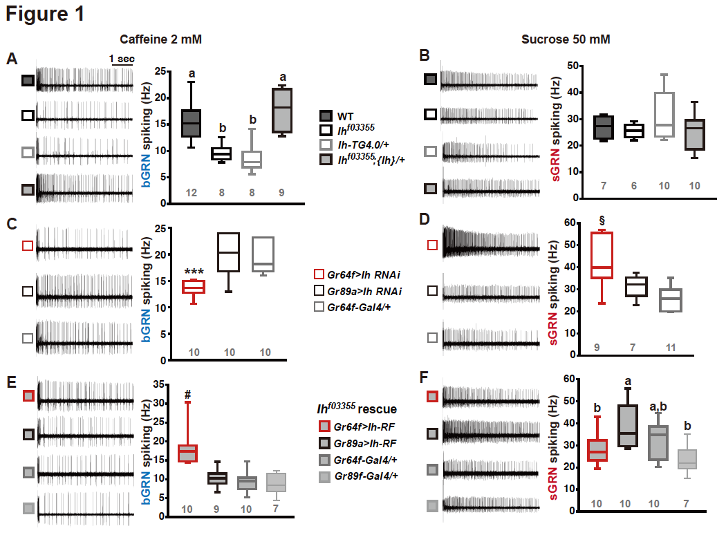

Fig. 1. HCN is necessary for the normal activity of bitter-sensing GRNs (bGRNs), although expressed in sGRNs. Representative 5 sec-long traces of sensillum recording with either caffeine or sucrose at the indicated concentration, shown along with box plots of spiking frequencies. (A) Caffeine-evoked bitter spiking responses of WT, the Ih-deficient mutants, Ih^{f03355} and Ih-TG4.0/+, and the genomic rescue, Ih^{f03355};{Ih}/+. (B) Sucrose responses were similar among the genotypes tested in (A). (C) Ih RNAi knockdown in sGRNs, but not bGRNs, reduced the bGRN responses to 2-mM caffeine. (D) Ih RNAi knockdown in sGRNs increased the sGRN responses to 50-mM sucrose. (E) Introduction of the Ih-RF cDNA in sGRNs, but not bGRNs, of Ih^{f03355} restored the bGRN response to 2-mM caffeine. (F) For sucrose responses, introduction of Ih-RF to bGRNs increased the spiking frequency. Letters indicate statistically distinct groups (a and b): Tukey’s test, p<0.05 (A), Dunn’s, p<0.05 (F). ***: Tukey’s t-test, 0.001. §: Welch’s ANOVA, Games-Howell test, p<0.05. #: Dunn’s test, p < 0.05. Numbers in gray indicate the number of experiments.

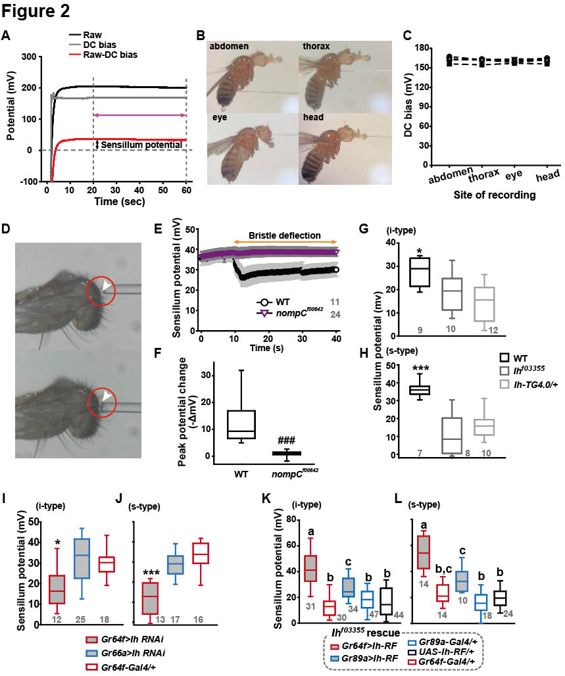

Fig. 2. Sensillum potential (SP) was reduced in HCN-deficient animals. (A) Representative traces of potentials measured to evaluate SP. Raw: the potential reading upon the contact of the recording electrode with the sensillum bristle tip (black). DC bias: the potential reading upon impalement of the head by the recording electrode (gray). Red line indicates the difference between raw and DC bias, which represents the sensillum potential. The values resulting from the subtraction of the data between 20 to 60 sec after the initial contact (time indicated by the purple double headed arrow) were averaged to determine SP. (B) Photographs of impaled flies for DC bias determination at indicated sites. (C) DC bias values obtained from indicated body parts. There is no statistical significance between the body sites (ANOVA Repeated Measures). (D) Photos before (top) and after (bottom) deflection of an i-type bristle. (E) Sensillum potential traces as a function of time of WT and nompC^{f00642}. Bristle bending started at 10 sec, and the duration is marked by an orange double headed arrow. (F) The peak SP changes of WT and nompC^{f00642} were compared. (G and H) SP was reduced in i- (G) and s-type (H) bristles of Ih-deficient mutants, relative to WT. (I and J) Ih RNAi in sGRNs reduced SP of the i- and s-type bristles. (K and L) The SP of Ih^{f03355} was restored by Ih-RF expression in GRNs (red for sGRNs, blue for bGRNs). *, ***: Tukey’s, p<0.05, p<0.001, respectively. ###: Dunn’s, p<0.001. Letters indicate statistically distinct groups: Tukey’s test, p < 0.05. Numbers in gray indicate the number of experiments.

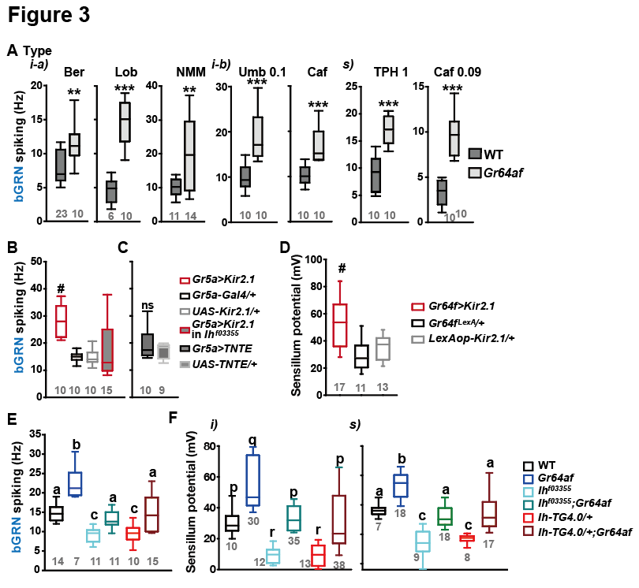

Fig. 3. Inactivation of sGRNs raised bGRN activity and SP, both of which were reversed by Ih deficiency. (A) The bGRN spiking was increased in response to the indicated bitters in sugar-ageusic Gr64af mutants. Ber: 0.5, Lob: 0.5, NMM: 2, Caf: 2 (i-type) and 0.09 (s-type), Umb: 0.1, TPH: 1 mM. * and ***: Student’s t-test, p<0.01 and p<0.001, respectively. (B and C) Silencing by Kir2.1 (B), but not blocking chemical synaptic transmission (C), in sGRNs increased the spiking of bGRNs stimulated by 2-mM caffeine, which was reversed in Ih^{f03355} (B). #: Dunn’s, p<0.05. (D) Silencing sGRNs by Kir2.1 increased SP. #: Dunn’s, p<0.05. (E) The increased bGRN spiking in Gr64af was restored to WT levels by Ih deficiencies. Letters indicate significantly different groups (Tukey’s, p<0.05). Caffeine 2 mM was used (B, C and E). (F) Regardless of bristle type, SP was increased upon sGRN inactivation, which was reduced by Ih deficiencies. p-r: Dunn’s test, p<0.05. a-c: Welch’s ANOVA, Games-Howell test, p<0.05. Numbers in gray indicate the number of experiments.

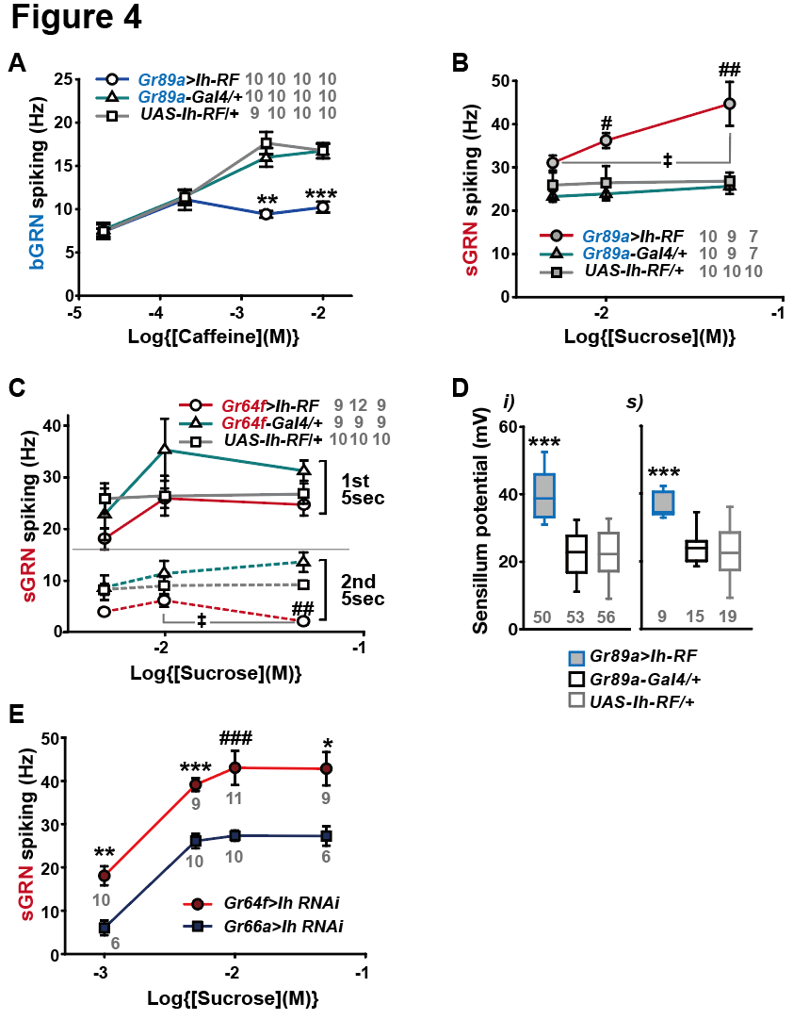

Fig. 4. HCN suppresses HCN-expressing GRNs and increases SP. (A) HCN misexpressed in bGRNs flattened the dose dependence to caffeine. (B) HCN ectopically expressed in bGRNs elevates sGRN responses to sucrose. # and ##: Dunn’s, p<0.05 and p < 0.01 between genotypes, respectively. ‡: Dunn’s, p < 0.05 between responses to 5- and 50-mM sucrose. (C) Overexpression of HCN in sGRNs reduced the sGRN responses to sucrose 5 sec after the initial contact. ##: Dunn’s, p < 0.01 between genotypes. ‡: Dunn’s p < 0.05 between responses to 10- and 50-mM sucrose. (D) Ih misexpression in bGRNs increased SP in i- and s-type bristles, which correlates with laterally increased sGRN activity (B). ***: Tukey’s, p<0.001. (E) Ih RNAi knockdown in sGRNs (Gr64f-Gal4 cells) dramatically elevates spiking frequencies in response to 1-, 5-, 10-, and 50-mM sucrose. *, **, and ***: Tukey’s, p<0.05, p<0.01, and p<0.001, respectively. ###: Dunn’s, p<0.001. The numbers of experiments are in grey.

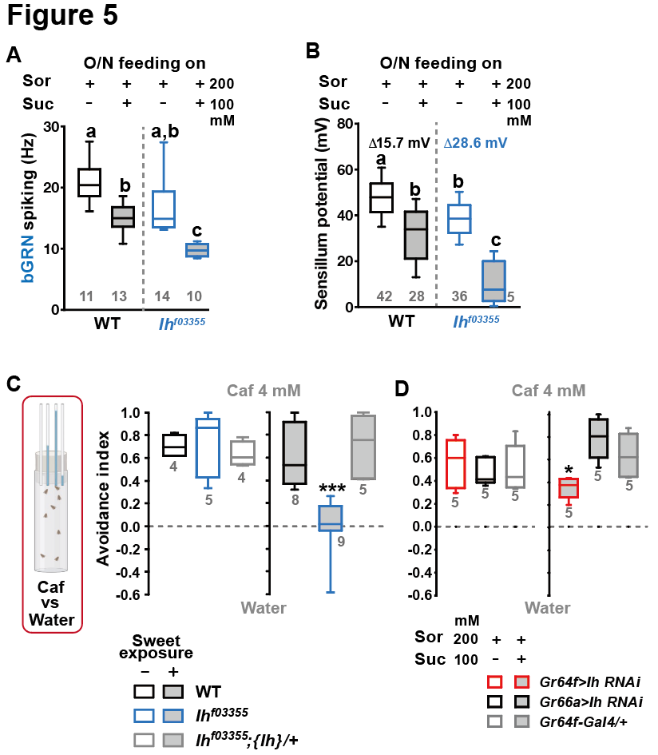

Fig. 5. Sweetness in the diet decreases in SP, bGRN activity, and bitter avoidance. (A) Sweetness in the media reduced the 2-mM caffeine-evoked bGRN spiking. Ih^{f03355} was affected by the type of the media more severely than WT. (B) The SP of Ih^{f03355} bristle sensilla showed the greatest reduction after incubation on sweet media. (C) Caffeine (Caf) avoidance was assessed with capillary feeder assay (CAFE). Ih is required for robust caffeine avoidance for flies maintained on sweet cornmeal food (sweet exposure +: filled boxes). Ih^{f03355} flies avoided 4 mM caffeine like WT flies when separated from sweet food for 20 hrs (blank boxes). (D) Ih RNAi knockdown in sGRNs (Gr64f-Gal4) but not bGRNs (Gr66a-Gal4) led to relatively poor avoidance to caffeine only with the sweet diet with sucrose. Suc: sucrose, and Sor: sorbitol Letters indicate statistically distinct groups: a-c, Dunn’s, p < 0.05 (A), or Tukey’s, p < 0.01 (B). * and ***: Tukey’s, p<0.05 and <0.001, respectively.

